**Practical-3**

**AIM: Allocating IP address to network topologies**

**Exercise-1(Note: Start allocation IP address number from PC0)**

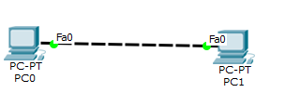

**Redraw above diagram which includes IP address and MAC address.Take IP address and MAC address as per your knowledge. Insert image below.**

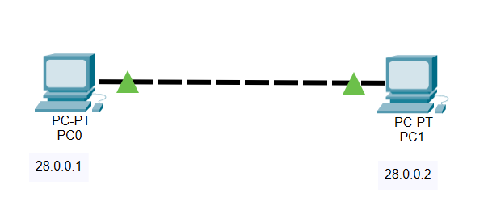

* **Ipconfig: fill table ipconfig of all computers**

**PC0**

|  |  |
| --- | --- |
| **Parameter** | **Value** |
| **Link local IPV6 Address** | **FE80::2D0:BAFF:FE08:8800** |
| **IP address** | **28.0.0.1** |
| **Subnet Mask** | **255.0.0.0** |
| **Default Gateway** | **0.0.0.0** |
|  |  |

**PC1**

|  |  |
| --- | --- |
| **Parameter** | **Value** |
| **Link local IPV6 Address** | **FE80::250:FFF:FEC7:1568** |
| **IP address** | **28.0.0.2** |
| **Subnet Mask** | **255.0.0.0** |
| **Default Gateway** | **0.0.0.0** |
|  |  |

* **Ipconfig /all: apply command on command prompt and write parameters and values in following table.**

**PC0**

|  |  |
| --- | --- |
| **Parameter** | **Value** |
| **Physial address** | **00D0.BA08.8800** |
| **Link local IPV6 Address** | **FE80::2D0:BAFF:FE08:8800** |
| **IP address** | **28.0.0.1** |
| **Subnet Mask** | **255.0.0.0** |
| **Default Gateway** | **0.0.0.0** |
| **DNS server** | **0.0.0.0** |

**PC1**

|  |  |
| --- | --- |
| **Parameter** | **Value** |
| **Physial address** | **0050.0FC7.1568** |
| **Link local IPV6 Address** | **FE80::250:FFF:FEC7:1568** |
| **IP address** | **28.0.0.2** |
| **Subnet Mask** | **255.0.0.0** |
| **Default Gateway** | **0.0.0.0** |
| **DNS server** | **0.0.0.0** |

* **Arp –a: before ping, write output of command from PC0 and PC1 computers**

**PC0**

**No ARP entries found**



**PC1**

**No ARP entries found**



* **Ping from PC0 to PC1 and vice versa and insert snap of output here.**

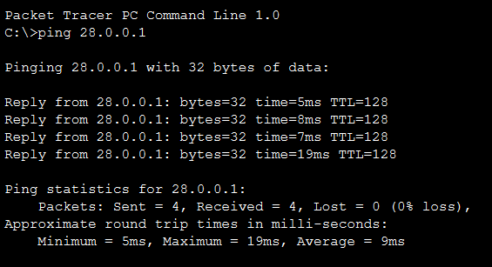

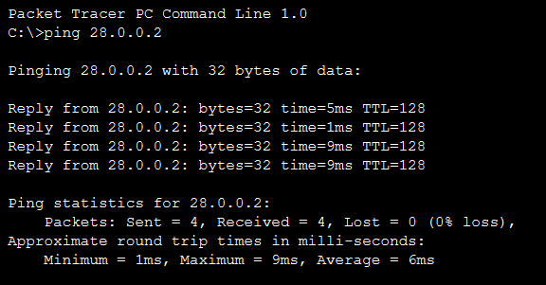

* **Arp –a: after ping, insert snap (below) of output of command from all computers**

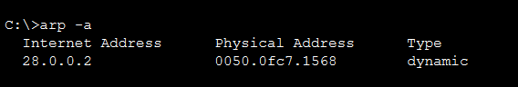

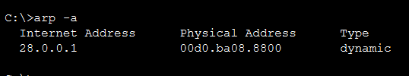

* **Netstat: insert snap of output of command from all computers**

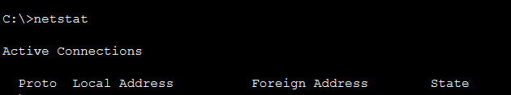

**------------------------------------------------------------------------------------------------------------**

**Exercise-2: (Note: Start allocation IP address number from PC0)**

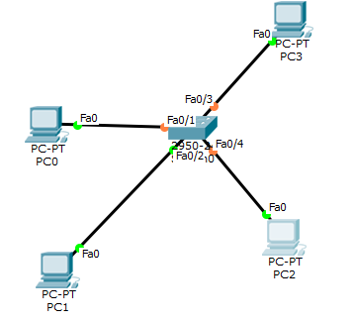

**Redraw above diagram which includes IP address and MAC address.Take IP address and MAC address as per your instruction. Insert image below.**

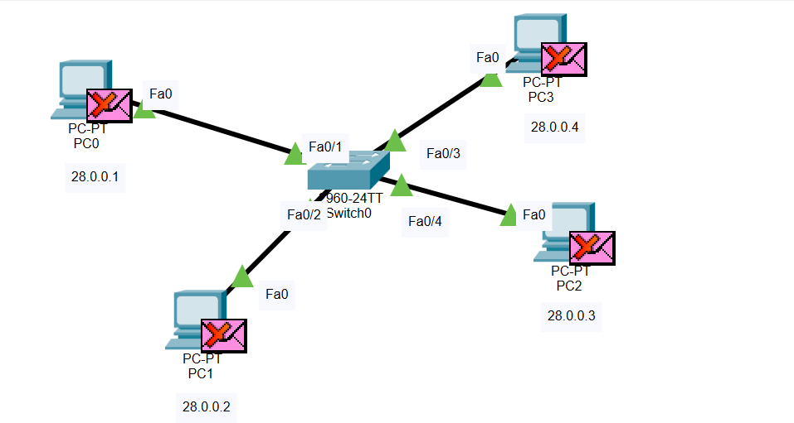

* **Ipconfig: fill table ipconfig of all computers**

**PC0**

|  |  |
| --- | --- |
| **Link local IPV6 Address** | **FE80::201:42FF:FE93:5956** |
| **IP address** | **28.0.0.1** |
| **Subnet Mask** | **255.0.0.0** |
| **Default Gateway** | **0.0.0.0** |

**PC1**

|  |  |
| --- | --- |
| **Link local IPV6 Address** | **FE80::201:42FF:FECB:129A** |
| **IP address** | **28.0.0.2** |
| **Subnet Mask** | **255.0.0.0** |
| **Default Gateway** | **0.0.0.0** |

**PC2**

|  |  |
| --- | --- |
| **Link local IPV6 Address** | **FE80::209:7CFF:FEC0:2E3D** |
| **IP address** | **28.0.0.3** |
| **Subnet Mask** | **255.0.0.0** |
| **Default Gateway** | **0.0.0.0** |

**PC3**

|  |  |
| --- | --- |
| **Link local IPV6 Address** | **FE80::2D0:97FF:FED2:8410** |
| **IP address** | **28.0.0.4** |
| **Subnet Mask** | **255.0.0.0** |
| **Default Gateway** | **0.0.0.0** |

* **Ipconfig /all: apply command on command prompt and write parameters and values in following table.**

**PC0**

|  |  |
| --- | --- |
| **Physical address** | **0001.4293.5956** |
| **Link local IPV6 Address** | **FE80::201:42FF:FE93:5956** |
| **IP address** | **28.0.0.1** |
| **Subnet Mask** | **255.0.0.0** |
| **Default Gateway** | **0.0.0.0** |
| **DNS server** | **0.0.0.0** |

**PC1**

|  |  |
| --- | --- |
| **Physical address** | **0001.42CB.129A** |
| **Link local IPV6 Address** | **FE80::201:42FF:FECB:129A** |
| **IP address** | **28.0.0.2** |
| **Subnet Mask** | **255.0.0.0** |
| **Default Gateway** | **0.0.0.0** |
| **DNS server** | **0.0.0.0** |

**PC2**

|  |  |
| --- | --- |
| **Physical address** | **0009.7CC0.2E3D** |
| **Link local IPV6 Address** | **FE80::209:7CFF:FEC0:2E3D** |
| **IP address** | **28.0.0.3** |
| **Subnet Mask** | **255.0.0.0** |
| **Default Gateway** | **0.0.0.0** |
| **DNS server** | **0.0.0.0** |

**PC3**

|  |  |
| --- | --- |
| **Physical address** | **00D0.97D2.8410** |
| **Link local IPV6 Address** | **FE80::2D0:97FF:FED2:8410** |
| **IP address** | **28.0.0.4** |
| **Subnet Mask** | **255.0.0.0** |
| **Default Gateway** | **0.0.0.0** |
| **DNS server** | **0.0.0.0** |

* **Arp –a: before ping write/snap of output of command from all computers**



* **Ping from PC0 to PC1 and vice versa and get the output here.**

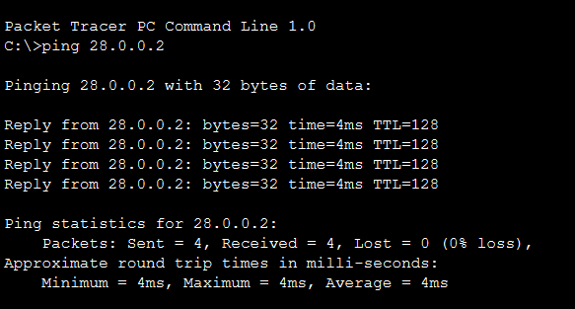

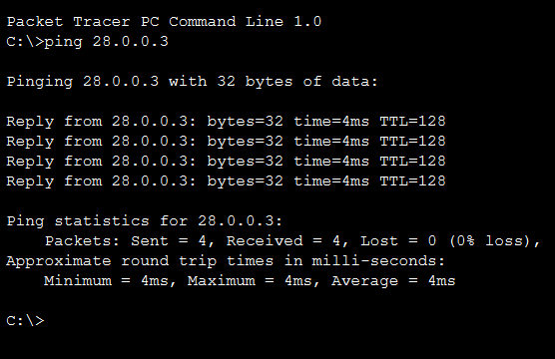

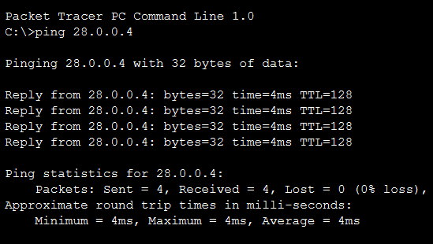

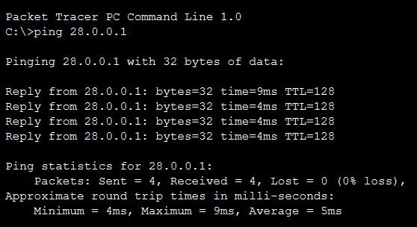

* **Arp –a: after ping write/snap of output of command from all computers**

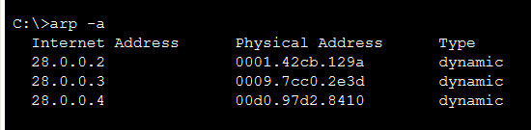

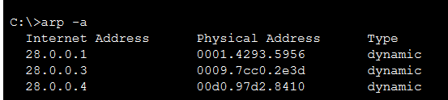

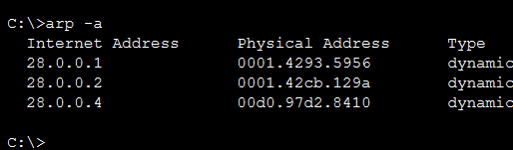

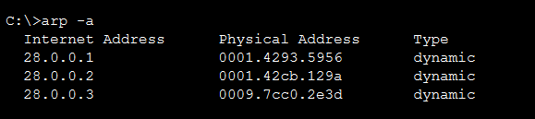

* **Netstat: write/snap of output of command from all computers**

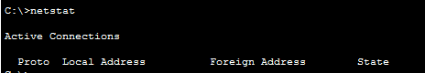

* **show ip route:write/snap of output of command from all computers**

**----------------------------------------------------------------------------------------------------------------**

**Exercise-3(Note: Start allocation IP address number from PC0)**

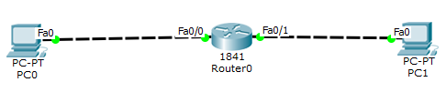

**Redraw above diagram which includes IP address and MAC address.Take IP address and MAC address as per your instruction. Insert image below.**

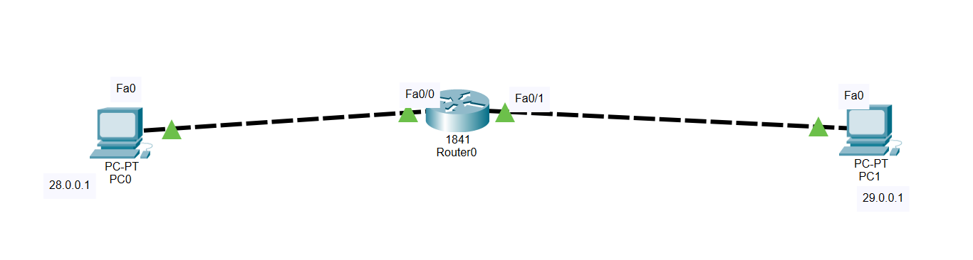

* **Ipconfig: fill following table with output of ipconfig of computer.**

**PC0**

|  |  |
| --- | --- |
| **Link local IPV6 Address** | **FE80::20A:F3FF:FE55:4947** |
| **IP address** | **28.0.0.1** |
| **Subnet Mask** | **255.0.0.0** |
| **Default Gateway** | **0.0.0.0** |

**PC1**

|  |  |
| --- | --- |
| **Link local IPV6 Address** | **FE80::2E0:A3FF:FE50:4B32** |
| **IP address** | **29.0.0.1** |
| **Subnet mask** | **255.0.0.0** |
| **Default gateway** | **0.0.0.0** |

* **Ipconfig /all: apply command on command prompt and write parameters and values in following table**

**PC0**

|  |  |
| --- | --- |
| **Link local IPV6 Address** | **FE80::20A:F3FF:FE55:4947** |
| **IP address** | **28.0.0.1** |
| **Subnet Mask** | **255.0.0.0** |
| **Default Gateway** | **0.0.0.0** |
| **Physical address** | **000A.F355.4947** |
| **DNS server** | **0.0.0.0** |

**PC1**

|  |  |
| --- | --- |
| **Link local IPV6 Address** | **FE80::2E0:A3FF:FE50:4B32** |
| **IP address** | **29.0.0.1** |
| **Subnet mask** | **255.0.0.0** |
| **Default gateway** | **0.0.0.0** |
| **Physical address** | **00E0.A350.4B32** |
| **DNS Server** | **0.0.0.0** |

* **Arp –a: before ping write/snap of output of command from all computers**

**No ARP entries found**



* **Ping from PC0 to PC1 and vice versa and get the output here.**

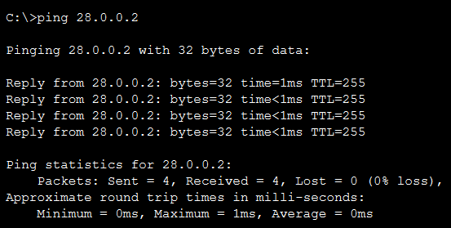

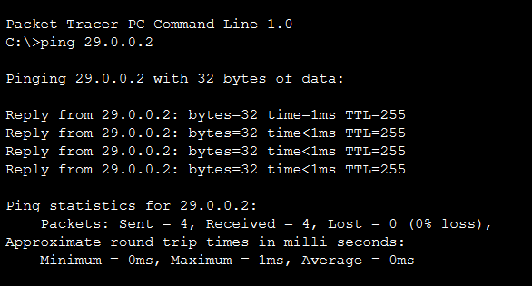

* **Arp –a: after ping write/snap of output of command from all computers**

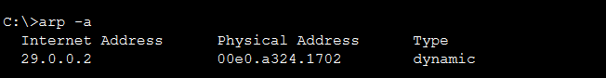

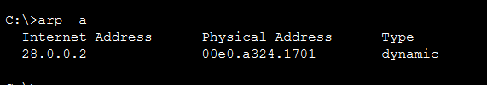

* **Netstat: write/snap of output of command from all computers**

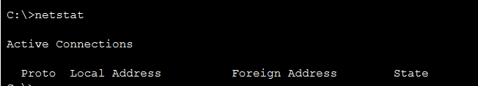

* **Ipconfig**

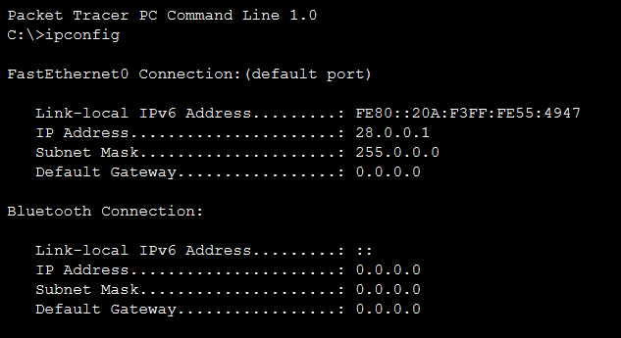

* **show ip route:write/snap of output of command from all computers**

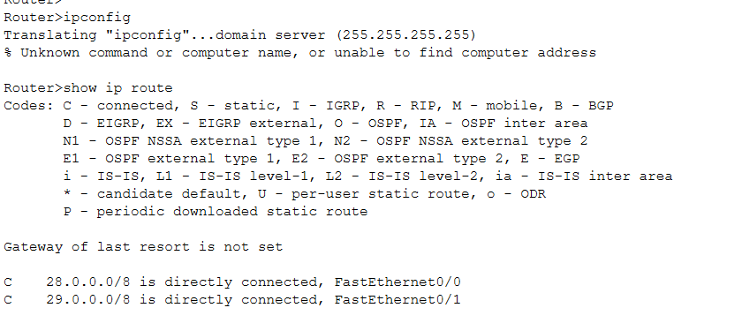

**----------------------------------------------------------------------------------------------------------------**

**Write answer of following questions.**

1. What are the conclusions of **ipconfig** command?

**Ans:**  It displays all the current TCP/IP network configuration values. It displays IPv4 and IPv6 address, Physical address, subnet mask, and default gateway for all adapters.

1. What are the conclusions of **ipconfig /all** command?

**Ans:** The Ipconfig /all command displays the full TCP/IP configuration for all adapters. Adapters can represent physical interfaces, such as installed network adapters, or logical interfaces, such as dial-up connections and local link IPv6 address.

1. What are the conclusions of **arp -a** command before ping?

**Ans:** It is used to display current Arp cache table for all interfaces. It shows no ARP entries found before ping because no ARP (Address Resolution Protocol) request was sent from either end devices.

1. What are the conclusions of **netstat**-r command after ping?

**Ans:** Netstat command shows you all the network connections on an end point. By invoking netstat command all of the open orts and connections are shown. The netstat –r command displays IP routing table. Hence, after ping there is an active connection established between two computers so it displays the active connection output.

1. What is my MAC address?

**Ans:** My MAC address is: 20-4E-F6-DB-5C-23

1. Which network configured? Static and Dynamic

**Ans:** A static IP address is simply an address that doesn't change. Once your device is assigned a static IP address, that number typically stays the same until the device is decommissioned or your network architecture changes.

Dynamic IP addresses are assigned by network using Dynamic Host Configuration Protocol (DHCP).

1. What is my gateway?

**Ans:** My Default gateway is: 192.168.1.1

1. What is hostname?

**Ans:** In [computer networking](https://en.wikipedia.org/wiki/Computer_networking), a hostname is a label that is assigned to a device connected to a computer networking and that is used to identify the device in various forms of electronic communication, such as the World Wide Web.

In the Internet, a hostname is a domain name assigned to a host computer. This is usually a combination of the host's local name with its parent domain's name.

1. What is my IPv6 address?

**Ans:** My IPv6 Address is: 2401:4900:1a7a:9eaf:e51b:cfa8:bdf3:807a

1. What is ARPA?

**Ans:** It is used to display current Arp cache table for all interfaces. It shows no ARP entries found before ping because no ARP (Address Resolution Protocol) request was sent from either end devices.

1. What is loopback address?

**Ans:** A loopback address is a special IP address, 127.0.0.1, reserved by InterNIC for use in testing network cards. This IP address corresponds to the software loopback interface of the network card, which does not have hardware associated with it, and does not require a physical connection to a network. The loopback address allows for a reliable method of testing the functionality of an Ethernet card and its drivers and software without a physical network. It also allows information technology professionals to test IP software without worrying about broken or corrupted drivers or hardware.

1. Port 80 means what.

**Ans:** Port 80 is the port number assigned to commonly used internet communication protocol, Hypertext Transfer Protocol (HTTP). It is the port from which a computer sends and receives Web client-based communication and messages from a Web server and is used to send and receive HTML pages or data.

1. What is difference between logical address and physical address?

**Ans:**

|  |  |
| --- | --- |
| **Logical Address** | **Physical Address** |
| It is a virtual address generated by CPU | The physical address is a location in the memory unit. |
| The user can directly access logical address. | The user cannot directly access the physical address. It uses logical address to access physical address. |
| The logical address is generated by CPU. | Physical address is computed by MMU(Memory management unit) |

1. What is NetBIOS?

**Ans:** NetBIOS (Network Basic Input/Output System) is a service that enables applications on different computers to communicate with each other across local area network (LAN). It was developed in the 1980s for use on early, IBM-developed PC networks. A few years later, Microsoft adopted NetBIOS and it became a de facto industry standard.